**Research Labs Inventory**

Jonathan Moore

Evan Ross

Lizzett Tapia

Sumedha Bhattacharyaa

**Research Lab Inventory**

**Final Report**

REVISION – Final

5 December 2024

**Table of Contents**

**Table of Contents** 2

**Execution Plan** 3

**Validation Plan**4

**Documents**

Concept of Operations Report (CONOPS) 6

Functional System Requirements (FSR) 19

Interface Control Document (ICD) 33

**Subsystem Reports**

Web Application 51

Database 77

Mobile Application 96

Machine Learning 113

**Execution Plan  
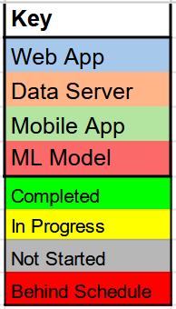**

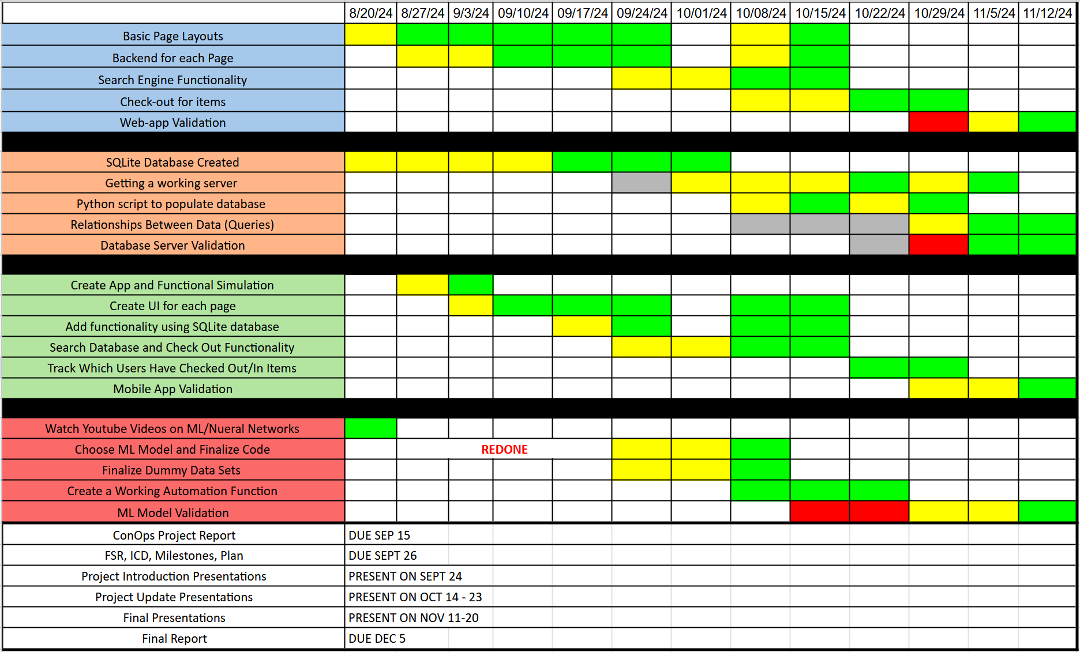

**Validation Plan**

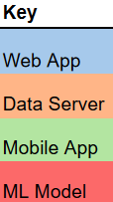

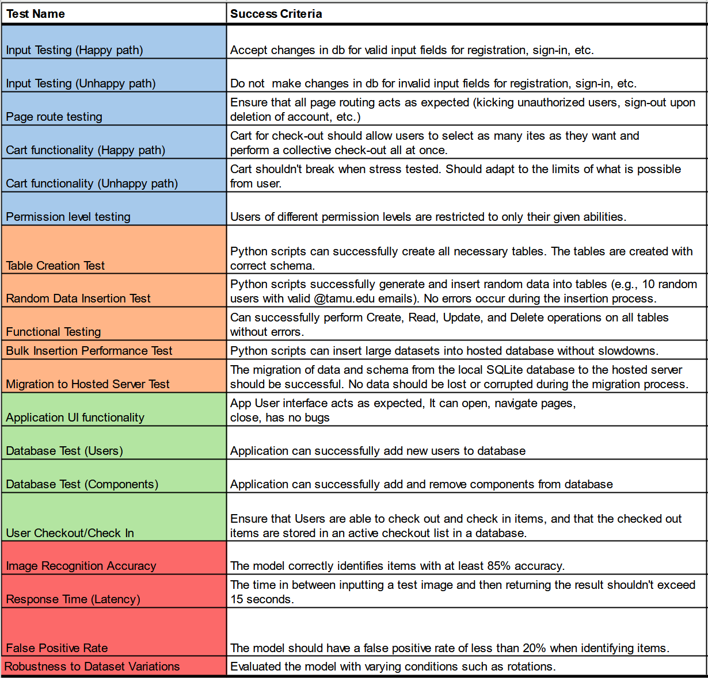

**Validation Plan Continued**



